Practical No 7

**John The Ripper**

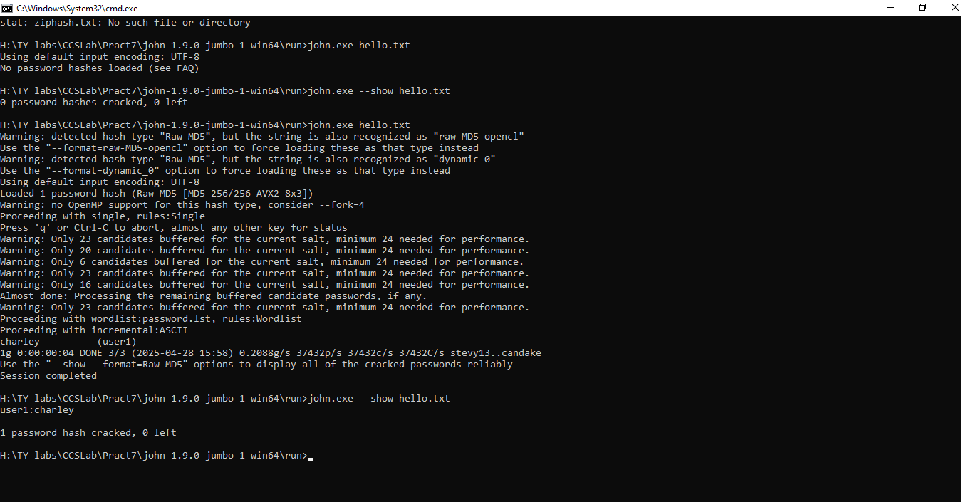

John The Ripper

>zip2john.exe hello.zip>ziphash.tx

>john.exe hello.txt

>john.exe --show hello.txt

**HashCat Tool**

>hashcat.exe -m 0 hello.txt

